44.31: In 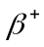decay, 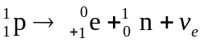
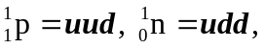so in decay a u quark changes to a d quark.

